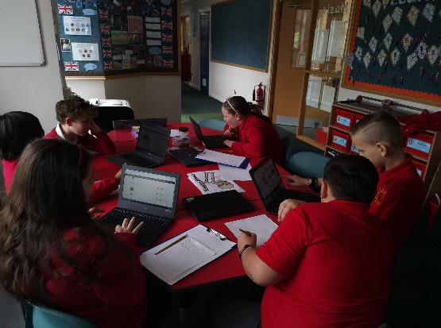
Sports Ambassadors meeting 30.9.22
Members present:
Mr Brassington
S.B G.J S.Q B.L P.B M.H L.D.P
Today in our meeting, the ambassadors were told that as a school we managed to raise over 1800 pounds through sponsorships during Sports Week through SPORTS4SCHOOLS. We now have an amazing opportunity to provide our school with some new sports equipment that can be used during breaktimes/lunchtimes as well as P.E.
We first went round the school asking the children and staff members from each class what new sports equipment that they would like. We got a range of different responses from netball posts to table tennis tables. The sports leaders then went onto the SPORTS4SCHOOLS website and then chose new sports equipment that we can using inspiration from others as well as their own ideas. They planned out how much certain items would cost, was it cheaper to buy certain things in bulk? All while staying within the budget.
In the afternoon we introduced the Sports Ambassadors to the new scheme we will be following throughout the year which is Play Makers. We discussed the programme and what is required from them in order to pass the course. Below is the first part of the scheme that we discussed.
What is a leader?
Often, when we talk about 'sports leadership' the word that jumps out to learners is 'sport' rather than 'leadership'. Most learners know what 'sport' is and they are comfortable with their feelings surrounding 'sport'. Fewer learners will be familiar with what 'leadership' is and most will not be so certain what might be involved in being a 'leader'.
A good way to start the programme may be to investigate a little further what 'leadership' is and what it takes to be a 'leader' so that everyone is comfortable and familiar with this aspect as much as with the 'sports' element.
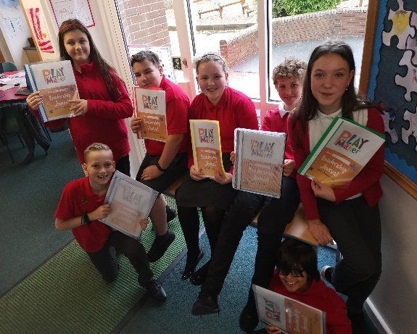
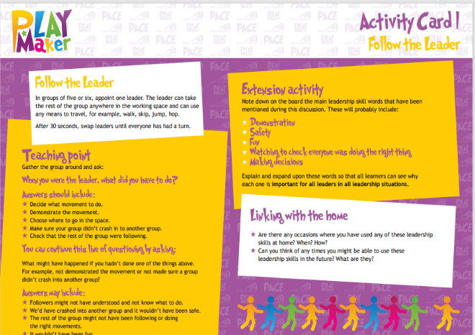
We then discussed the first activity card that the leaders would have to follow and how the prepare themselves for running a session by using a session planner such as equipment and area.

