Nursery: 22-36 months
Selects a small number of objects from a group when asked, for example, ‘please give me one’, ‘please give me two’.
Creates and experiments with symbols and marks representing ideas of number
Begins to make comparisons between quantities.
Uses some language of quantities, such as ‘more’ and ‘a lot’
Knows that a group of things changes in quantity when something is added or taken away.
Representations | Key knowledge and vocabulary | Concrete & pictorial  Conceptual modelling | Abstract  Skills and knowledge | Application across the environment
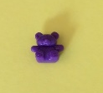  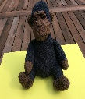  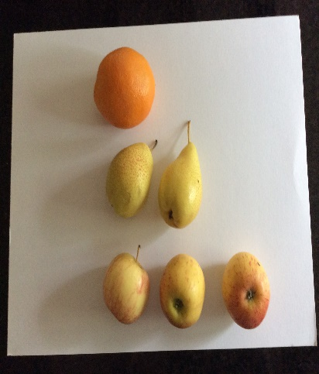  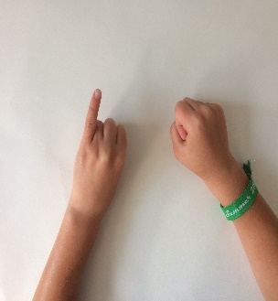  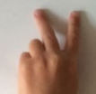  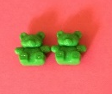  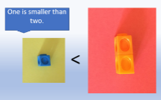 | Concepts of quantity, equality and inequality.  Modelling combining sets of small quantities.  Modelling adding to a quantity to make it bigger.  Removing objects from a set to show the amount is now smaller. | Natural materials and physical objects in all environments.  Pictures to show one or two items.  Objects and resources to physically represent a quantity. Images and pictures to represent a small quantity.  Using dishes/hoops to make quantities of different values that visually show one set has more than the other.  Images of quantities to compare. Which has more? | Spoken number names.  One, once, alone, first.  Mark making and graphics to represent a small number in the context of play.  Mark making and graphics to represent a small quantity to compare in the context of play. | Wonderful one and terrific two displays.  Hiding objects find one of, or lots of in the sand, across the setting.  Matching one item to another then to one image.  Repeat with two.  Snack time: one piece of fruit to one person, two pieces each  Problem solving: “We need one/two each how can we sort the bears?”

Nursery/Reception: 30 - 50 months
Knows that numbers identify how many objects are in a set.
Beginning to represent numbers using fingers, marks on paper or pictures.
Sometimes matches numeral and quantity correctly.
Compares two groups of objects, saying when they have the same number.
Separates a group of three or four objects in different ways, beginning to recognise that the total is still the same.
Shows an interest in representing numbers.
Representations | Key Vocabulary | Key knowledge | Concrete & pictorial  Conceptual modelling | Abstract  Skills and knowledge | Application across the environment
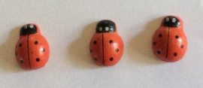  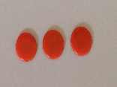  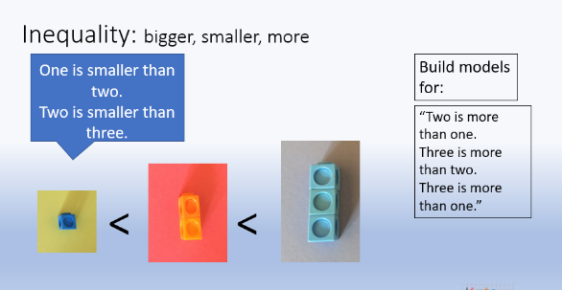  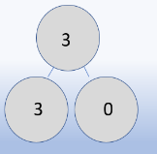  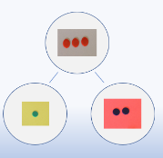  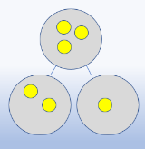 | Layers of vocabulary  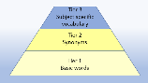  Appendix 1a  Beck’s Tiers of Vocabulary  Appendix 1b: Vocabulary book  Basic to subject specific (Beck’s Tiers):  Add, more, and, make, sum, total, altogether, double, how many  Instructional vocabulary:  Listen, join in, say, start from, look at, carry on | Concepts of cardinality, equality, inequality and rearranging the same quantity.  Counting to 3. One to one correspondence. Knowing how many are in the set.  Comparing numbers 1,2 and 3 – ‘bigger’ and ‘smaller’  Stable ordering numbers 1 to 3.  3 is made up of 2 and 1.  Using counting strategies and subitising to identify the number of concrete objects in the set. | Natural materials and physical objects in all environments to count. (cardinality)  Pictures to show a quantity that can be counted.  Use fingers to show small amounts.  Images and pictures to represent a small quantity.  Resources that match a numeral to a quantity. E.g. a number track, digits cards with numerals and quantities represented. | Represent a quantity by drawing.  Mark making and graphics to represent a small quantity and attempts at numerals.  Mark making and drawings to replicate the concrete and pictorial model.  With models, attempts to write numerals and continue to mark make. | Construction.  What can you make with 3 / 4 bricks?  Small world.  Put three carriages on the train.  How many cars are in the car park?  How many skittles have you knocked over?  Mark making and graphics to represent a small number in the context of play.

Reception: 40 - 60 months
Counts up to three or four objects by saying one number name for each item.
Counts objects to 10 and beginning to count beyond 10.
Selects the correct numeral to represent 1 to 5, then 1 to 10 objects.
Uses the language of ‘more’ and ‘fewer’ to compare two sets of objects.
Finds the total number of items in two groups by counting all of them.
Says the number that is one more than a given number.
In practical activities and discussion, beginning to use the vocabulary involved in adding and subtracting.

Representations | Key Vocabulary | Key knowledge and vocabulary | Concrete & pictorial  Conceptual modelling | Abstract  Skills and knowledge | Application across the environment
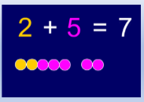  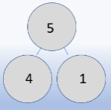  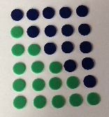  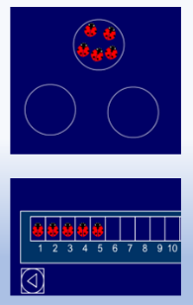  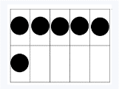  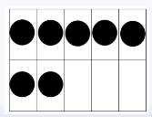 | Layers of vocabulary  Appendix 1a  Beck’s Tiers of Vocabulary  Appendix 1b: Vocabulary book  Basic to subject specific (Beck’s Tiers):  Add, more, and, make, sum, total, altogether, double, how many more to make, how many are left, how many have gone?  Instructional vocabulary:  Listen, join in, say, start from, look at, carry on, what comes next, find, choose, talk about | Number structure.  Equality, inequality.  Partitioning and recombing.  Subitising to 5. 5 as an anchor.  Modelling the combining of sets, recognising that the quantity has increased.  Using counting strategies and subitising to identify the number of concrete/pictorial objects in the set  . | Natural materials, physical objects and mathematical resources e.g. counters in all environments to count accurately. (cardinality).  To 10 and beyond.  Pictures to show a quantity that can be counted then to 10 and beyond.  Resources that match a numeral to a quantity  Models of mathematical counting resources to show the more or fewer.  Using a number track or line to show one more than a given number | Represent a quantity by drawing or by using graphics. (using drawings to show a resource)  Mark making and graphics to represent numbers to 10 and beyond in their play.  Graphics and attempts at numerals in the correct orientation.  Mark making and numerals to replicate the concrete and pictorial model.  Graphics and numerals to show the addition | Malleable play: problem solving  ‘Let’s put 5 cherries on the cakes.’  ‘How will you put your 5 candles on the two cakes?’  Role play: problem solving  Each shelf in the shop must have 5 or more items to sell.  How shall we arrange the items?  Find items in the sand.  3 shells and 2 fish. How many items altogether?

Reception: ELG 2018
Numbers to 20: place them in order and say which number is one more or one less than a given number
Using quantities and objects, they add and subtract two single-digit numbers and count on or back to find the answer
They solve problems, including doubling, halving and sharing.
Representations | Key Vocabulary | Key knowledge and vocabulary | Concrete & pictorial  Conceptual modelling | Abstract  Skills and knowledge | Application across the environment
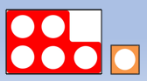  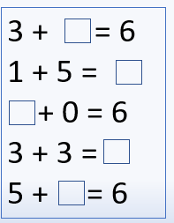  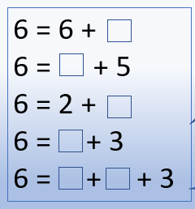 | Layers of vocabulary  Appendix 1a  Beck’s Tiers of Vocabulary  Appendix 1b: Vocabulary book  Basic to subject specific (Beck’s Tiers):  Add, more, and, make, sum, total, altogether, double, how many more to make, how many are left, how many have gone?  One less, two less, ten less, the difference between, odd and even.  Instructional vocabulary:  Listen, join in, say, start from, look at, carry on, what comes next, find, chose, talk about, repeat, tell me, describe, complete | Number structure.  Equality, inequality.  Partitioning and recombing.  Subitising to 5. 5 as an anchor.  Modelling the combining of sets, recognising that the quantity has increased.  Using counting strategies and subitising to identify the number of concrete/pictorial objects in the set  . | Natural materials, physical objects and mathematical resources e.g. counters in all environments to count accurately. (cardinality).  To 10 and beyond.  Pictures to show a quantity that can be counted then to 10 and beyond.  Resources that match a numeral to a quantity  Models of mathematical counting resources to show the more or fewer.  Using a number track or line to show one more than a given number | Represent a quantity by drawing or by using graphics. (using drawings to show a resource)  Mark making and graphics to represent numbers to 10 and beyond in their play.  Graphics and attempts at numerals in the correct orientation.  Mark making and numerals to replicate the concrete and pictorial model.  Graphics and numerals to show the addition | Malleable play: problem solving  ‘Let’s put 5 cherries on the cakes.’  ‘How will you put your 5 candles on the two cakes?’  Role play: problem solving  Each shelf in the shop must have 5 or more items to sell.  How shall we arrange the items?  Find items in the sand.  3 shells and 2 fish. How many items altogether?
Reception: ELG 2018
Numbers to 20: place them in order and say which number is one more or one less than a given number
Using quantities and objects, they add and subtract two single-digit numbers and count on or back to find the answer
They solve problems, including doubling, halving and sharing.
Representations | Key Vocabulary | Key knowledge | Concrete & pictorial  Conceptual modelling | Abstract  Skills and knowledge | Application across the environment
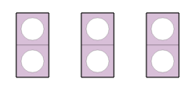  Counting in 2s  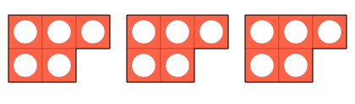  Counting in 5s  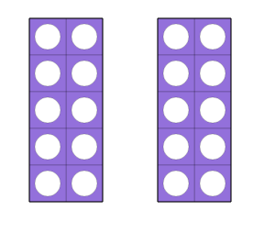  Double 10 is 20.  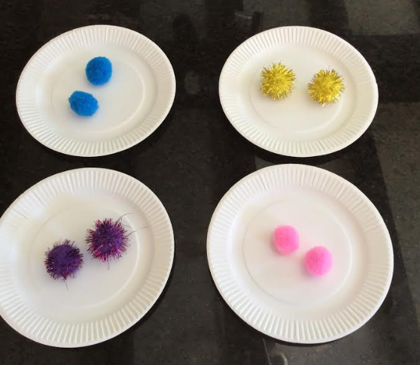  8 divided in to groups of 2.  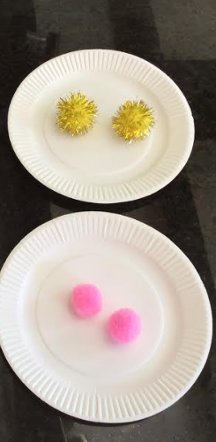  4 shared equally into two groups.  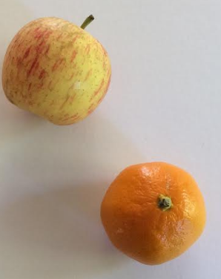  To halve the apple it would be cut into two equal pieces  To halve the satsuma we would count the segments and share them equally.  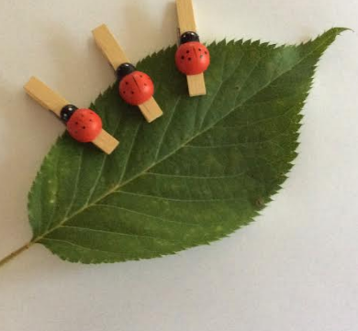  Double the number of ladybirds.  This show half the number of lady birds sitting on the leaf.  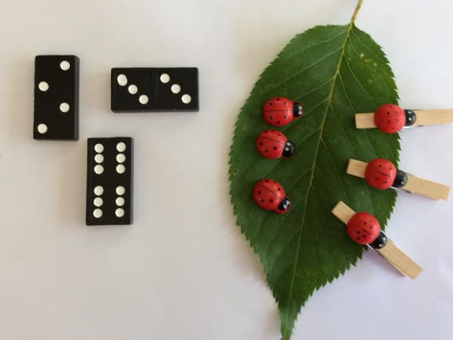  Doubling and halving. | Layers of vocabulary  Appendix 1a  Beck’s Tiers of Vocabulary  Appendix 1b: Vocabulary book  Basic to subject specific (Beck’s Tiers):  Add, more, and, make, sum, total, altogether, double, how many more to make, how many are left, how many have gone?  One less, two less, ten less, the difference between, odd and even. Equals, share, groups of, halve and half  Instructional vocabulary:  Listen, join in, say, start from, look at, carry on, what comes next, find, choose, talk about, repeat, tell me, describe, complete, pattern, remember, ring, work out, check, another way | Knowing that groups of the same quantity are added together. That is what makes a double.  The quantity divided into two equal groups. Halving.  Sharing and grouping.  Sharing is where you take a quantity and count out into how many equal groups you want.  Grouping is where you take the quantity and make the groups (of two, or three etc) | Natural materials, physical objects and mathematical resources e.g. counters in all environments to double, share, group and half accurately.  Modelling and demonstrating groups of and shared quantities.  Showing that the quantity has increased when doubled and reduced when halved. | Represent a quantity by drawing or by using graphics. (using drawings to show a resource)  Graphics and numerals to show the double/halving/grouping and sharing used. | In small world play:  All the animals in the enclosures are doubles. How many lions will there be etc?  Doubles shop  Everything in the shop has to be double.  Snack time  How will we share the fruit so that we can have half each?

